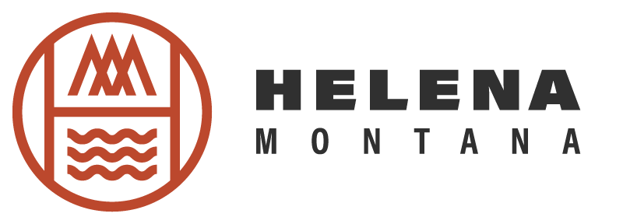

Program and Event Report / APRIL 2026

Event Programing:
- Winter TBID Event Grants:
  - Montana Outdoor Expo happened in March. Working with them for post event reports.

Helena Tourism Programs / Support:
- Julian Anderson Trail Line:
  - SOVRN currently working on branding and content.
  - Map and Staff & Server Guide in draft stage.
  - Scheduled to officially roll out end of June with soft launch end of May.
- Outdoor Adventure Show / Calgary
Local Stakeholders:
- Second stakeholder email sent out. This newsletter is directed to business owners so we can efficiently share with them big business weekends, importance of tourism and guest service, event listings that qualify with our standards.

