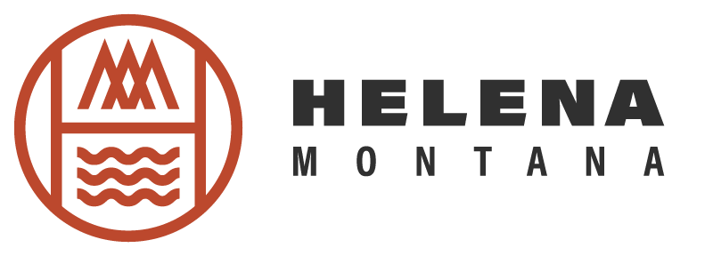

Program and Event Report / March 2026

Event Programing:
- Winter TBID Event Grants:
  - Montana Outdoor Expo :
    - Post Event report presented to board.
Helena Tourism Programs / Support:
- Julian Anderson Trail Line
  - Maps, rack cards, website, trail markers in final stages
  - Setting up staff training appointments with partners
- Outdoor Adventure Show / Denver:
- Attendee Survey report presented to board.

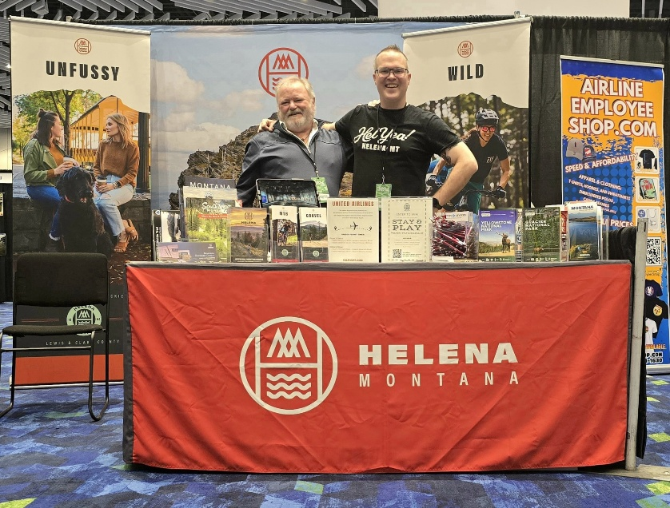

Hotel Support:
- QR Cards
  - EVENTS / TASTES card clicks Month of April 1st-30th *:
    - TASTES: 26 U.S.
    - EVENTS: 14 U.S.
*These cards have been distributed to 85% of TBID Lodging Partners. It has been highly encouraged that hotels place these cards in hotel room key sleeves.
Additionally, they are available at The Montana Heritage Museum.
  - DWNTWN / QUESTS card clicks Month of Month of April 1st-30th **:
    - DWNTWN: 3 U.S.
    - QUESTS: 8 U.S.
**These cards have been distributed to 25% of TBID Lodging Partners, are located outside of Downtown Helena, and experience a high volume of guests. These cards have been encouraged to have at front desk. Data will present how we move forward.
Additionally, they are available at The Montana Heritage Museum.
- Weekend Call Around
  - Will pick back up in May, 2026
Local Stakeholders:
- Continuing Business Stakeholder Emails that compliment monthly newsletters. The Stakeholder emails are to inform and provide insight to Helena Tourism.

